**Assignment 05 Solutions**

**1. What are Sequence-to-sequence models?**

**Ans:** Sequence to Sequence (often abbreviated to seq2seq) models is a special class of Recurrent Neural Network architectures that we typically use (but not restricted) to solve complex Language problems like Machine Translation, Question Answering, creating Chatbots, Text Summarization, etc.

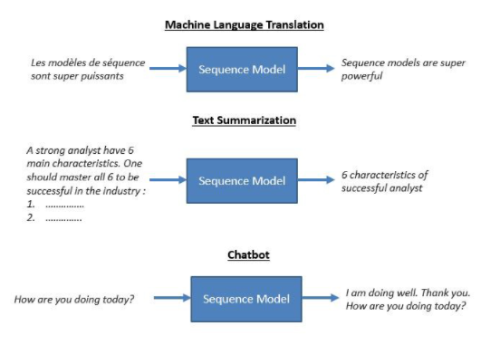

#### 2. What are the Problem with Vanilla RNNs?

**Ans:** RNNs suffer from the problem of vanishing gradients, which hampers learning of long data sequences. The gradients carry information used in the RNN parameter update and when the gradient becomes smaller and smaller, the parameter updates become insignificant which means no real learning is done.

#### 3. What is Gradient clipping?

**Ans:** Gradient clipping is a technique to prevent exploding gradients in very deep networks, usually in recurrent neural networks. A neural network is a learning algorithm, also called neural network or neural net, that uses a network of functions to understand and translate data input into a specific output.

This type of learning algorithm is designed based on the way neurons function in the human brain. There are many ways to compute gradient clipping, but a common one is to rescale gradients so that their norm is at most a particular value. With gradient clipping, pre-determined gradient threshold be introduced, and then gradients norms that exceed this threshold are scaled down to match the norm. This prevents any gradient to have norm greater than the threshold and thus the gradients are clipped. There is an introduced bias in the resulting values from the gradient, but gradient clipping can keep things stable.

#### 4. Explain Attention mechanism

**Ans:** The attention mechanism was introduced to improve the performance of the encoder-decoder model for machine translation. The idea behind the attention mechanism was to permit the decoder to utilize the most relevant parts of the input sequence in a flexible manner, by a weighted combination of all of the encoded input vectors, with the most relevant vectors being attributed the highest weights.

#### 5. Explain Conditional random fields (CRFs)

**Ans:** Conditional random fields (CRFs) are a class of statistical modeling methods often applied in pattern recognition and machine learning and used for structured prediction. Whereas a classifier predicts a label for a single sample without considering "neighbouring" samples, a CRF can take context into account.

#### 6. Explain self-attention

**Ans:** Self Attention, also called intra Attention, is an attention mechanism relating different positions of a single sequence in order to compute a representation of the same sequence. It has been shown to be very useful in machine reading, abstractive summarization, or image description generation.

#### 7. What is Bahdanau Attention?

**Ans:** Conventional encoder-decoder architectures for machine translation encoded every source sentence into a fixed-length vector, irrespective of its length, from which the decoder would then generate a translation. This made it difficult for the neural network to cope with long sentences, essentially resulting in a performance bottleneck.

The Bahdanau attention was proposed to address the performance bottleneck of conventional encoder-decoder architectures, achieving significant improvements over the conventional approach.

The Bahdanau attention mechanism has inherited its name from the first author of the paper in which it was published.

#### 8. What is a Language Model?

**Ans:** Language modeling (LM) is the use of various statistical and probabilistic techniques to determine the probability of a given sequence of words occurring in a sentence. Language models analyze bodies of text data to provide a basis for their word predictions. They are used in natural language processing (NLP) applications, particularly ones that generate text as an output. Some of these applications include , machine translation and question answering.

#### 9. What is Multi-Head Attention?

**Ans:** Multi-head Attention is a module for attention mechanisms which runs through an attention mechanism several times in parallel. The independent attention outputs are then concatenated and linearly transformed into the expected dimension. Intuitively, multiple attention heads allows for attending to parts of the sequence differently (e.g. longer-term dependencies versus shorter-term dependencies).

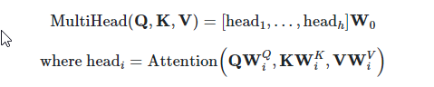

#### 10. What is Bilingual Evaluation Understudy (BLEU)

**Ans:** BLEU, or the Bilingual Evaluation Understudy, is a score for comparing a candidate translation of text to one or more reference translations.

Although developed for translation, it can be used to evaluate text generated for a suite of natural language processing tasks.